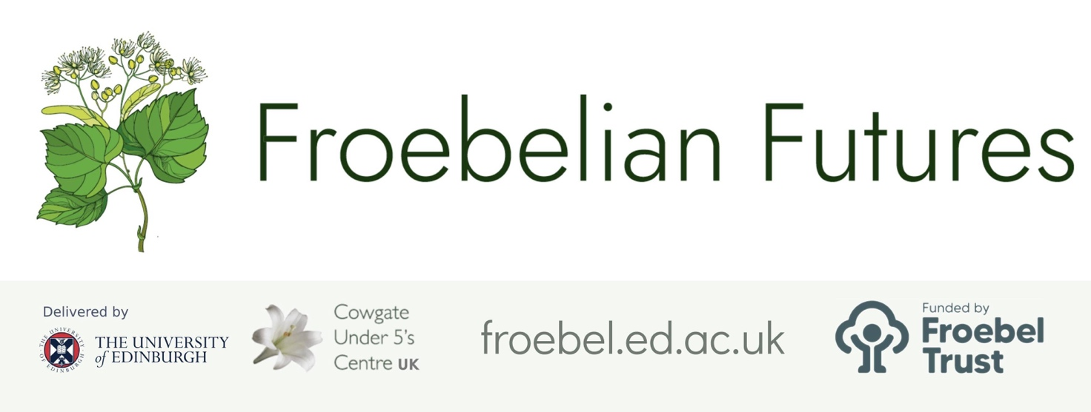

Practitioner Inquiry Project Report
Leadership opportunities & reflections

Project title

“Mealtime Experience’

Subtitle (if applicable)

Your name and role
Laura Grattan-Nursery Manager

- What are the implications of this research for:

- The team/setting as a whole
- Pedagogy
- Resourcing
- Policy
- The sector / your networks / management beyond your immediate setting.

(Please aim to write between 250 minimum and 500 words maximum, using the box below. Please do not disclose the identity of any individuals in your comments, as this form will be part of your colleague’s public record of their project).

This project has given us as a whole team the opportunity for reflection and deep thinking around our mealtimes within the setting. Reflecting on our mealtimes with the staff team, we felt that is something that’s part of our daily routine and something that could almost be carried out within out a second thought by us all. The conversations I have had with other colleagues and professionals around this area I knew that the Care Inspectorate were carrying out focused observations around mealtimes, so keeping this in mind I wanted to make a it a priority for improvement and development for us a setting.

Taking part in a research project over the last year has been challenging at times due to the current times this sector has faced this includes staff shortages, illness and Government Guidelines and policies put in place due to COVID-19. Managing this within my team has meant I could not implement what we had planned at times for this research project or that this has had to take a backseat while we focused on other factors.

I have had discussions with staff through meetings, one to ones and this involved valuing this time of our day and how this we can improve this with research.

We have always had nursery policies reflecting Healthy Eating, however on reflection this only touched briefly on the social interactions and the benefits of mealtimes within the setting. I’m now revisiting this policy and including my finding from this research stating within the policy how much we truly value Mealtimes and as a setting we include our Staff, children and families within this wonderful part of our daily routine.

- What value do you place on practitioner-research – and what more can be done in your setting/locality to enable it to continue as part of routine practice going forward?

Undertaking this research project with the support of our local authority and the Froebel network meant we had the opportunity to take time within a busy environment to truly value research on a focused part of our practice. Being involved in this project has given me an understanding of what is involved in a research project, what it entails and what steps to take through the process. It has given me time to reflect on why and how we implement chances within the setting, going forward how I will view and undertake future changes/developments.

I value that as a leader I need to ensure I’m taking my team along with me through any improvements, changes and developments. This is why within the research project we have chosen something that collectively as a team we have thought deeply about and reflected on as an aspect we strongly

- What have you learned as a leader through supporting this research / programme? (100 words)

Within our nursery Vision, Values and Aims we state that ‘every day is a learning day’ and this rings true when I reflect on this project. I had assumptions of what staff would feedback to me regarding the observation/questionaries and from the feedback comments I was pleasantly surprised. I will now use differ process to gather me staff views within different areas to open my eye to their true views of practice.

I feel as a leader this it has now provided me with the tools, skills and drive to take on more research projects using the same process.

Please save this document as a PDF and share it as feedback with your researching practitioner/colleague and with us at froebelianfutures@ed.ac.uk. Please ask them to upload it to their project report page (Edit > Question 12) as a condition of completing their certificate.
If you have any questions about this process please contact us at the email address above.

