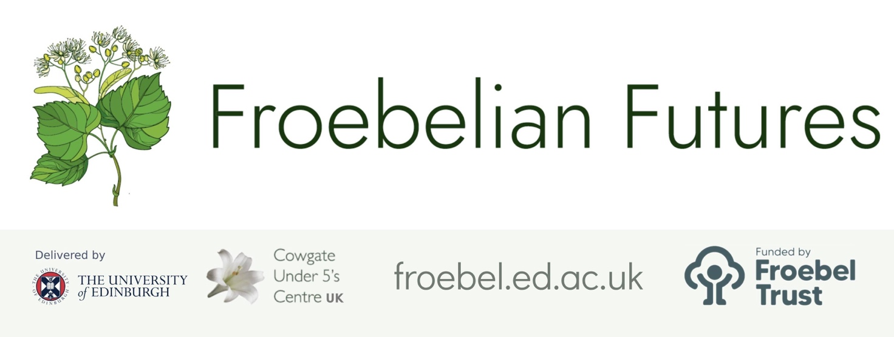

Practitioner Inquiry Project Report
Leadership opportunities & reflections

Project title

How is mark-making encouraged in our outdoor environment?

Subtitle (if applicable)

Your name and role
Alison J Hawkins (Lead) Moira Whitelaw (Practitioner)

- What are the implications of this research for:

- The team/setting as a whole
- Pedagogy
- Resourcing
- Policy
- The sector / your networks / management beyond your immediate setting.

(Please aim to write between 250 minimum and 500 words maximum, using the box below. Please do not disclose the identity of any individuals in your comments, as this form will be part of your colleague’s public record of their project).

Although this research was primarily looking at how mark-marking exists in the outdoor areas of one inner city kindergarten, its value went far beyond the findings, and beyond how those findings impact positively on children. Some practitioners are still in the early stages of their personal Froebelian journeys, and most have never before been involved in research. The research proved to be invaluable in facilitating questioning, discourse and professional dialogue, leading to subsequent shifts in practice and overall a greater understanding of Froebelian practice.

An over-riding benefit was the opportunity for myself and the lead practitioner to work closely together. The training, reading and debates served to confirm a unity of thought and purpose, and coupled with the involvement of the staff team, magnified the already present collegiate work.

As staff focused on observing how mark-making was provided, and used, outdoors, so their knowledge and understanding of Froebelian principles increased. ‘Freedom with Guidance’ was frequently debated, and confidence in allowing children to follow their unique creative interests unhindered and unhurried, rose. In keeping with our philosophy, ‘resources’ are provided throughout the environment and children free-flow, engaging in solitary or group play. Their learning is holistic, and we hope unrestricted by time or practice constraints.
We noticed certain children – who regularly choose traditional mark-making tools (paper, crayons, paint...), and like to model-make, design, and draw/paint - became frustrated as the elements worked against them. We made certain sheltered areas were provided.
However, through considered modelling by staff, children adapted their practice and would create using natural materials, placing them in large frames made from sticks which had been coppiced (with permission!) from a local woodland area. These creations often accompanied children’s stories linking therefore, their inner thoughts, or feelings, and expressing them in a symbolic manner.
Role play, sand play and mixing mud appeared to be the manner in which children less likely to use paper and pencil made their marks. A benefit of vertical grouping became apparent in that the influence of children who possess ‘better developed’ writing skills, was obvious. If B, aged four, with charcoal from the campfire, made a detailed map it was likely C aged 3 would copy. Likewise block or cardboard structures were often covered in chalk marks or labels added to by children of all ages.

From this staff recognised the wider interpretations of mark-making.

Overall, the research project was successful in its aim to determine how mark-making is encouraged in our outdoor areas, but probably had its greatest impact in the increase in staff knowledge, and subsequent practice. Such has been the interest ignited that we now intend to look more closely at ‘why mark-making is important’ and ‘how does it relate to emergent writing?’.

We intend to share our research findings with the parent body, with our local Froebelian network, and (if asked) with the Local authority with whom we are in partnership.

- What value do you place on practitioner-research – and what more can be done in your setting/locality to enable it to continue as part of routine practice going forward?

The setting is relatively inexperienced in carrying out practitioner-research. The project helped us focus on an area of practice which had been causing concern, but the overwhelming positive came from the increased collaboration, and subsequent extension of knowledge of staff members.
We have already planned to carry the research forward, and examine the purpose of mark-making, while observing how the children in our setting develop ‘writing’.

“The appreciation young children feel for the rest of their lives towards those adults who have contributed in a major way to how they feel about themselves as learners is rarely spoken. It is an abstract, intuitive thing which they take with them through their lives. And yet, it anchors them forever...good teachers help you to learn the things you find hardest in ways which are right for you. (Bruce, 2020:24 and 26).

Bruce’s quote summed up for us the significance of quality interaction amongst staff and children, and reminded us that Continuing Professional Development/Research is important
as a way of ensuring children experience the best practice possible.

- What have you learned as a leader through supporting this research / programme? (100 words)

-that staff know more than they sometimes think they do, which raises their confidence ie in part leadership follows they same journey as supporting children: start where the learner is, and scaffold from there
- that working co-operatively and sharing ideas enhances the learning of all.

That Froebel’s principles permeate all that we ‘do’ in our setting – and that I can provide the materials/books to enable staff to discover the relevance of his principles in the 21st C -- and associate them to practice.

“Once everyone understands their value, we stop hustling for worthiness and lean in to our gifts” (Brown, B. 2018:98)

Please save this document as a PDF and share it as feedback with your researching practitioner/colleague and with us at froebelianfutures@ed.ac.uk. Please ask them to upload it to their project report page (Edit > Question 12) as a condition of completing their certificate.
If you have any questions about this process please contact us at the email address above.

