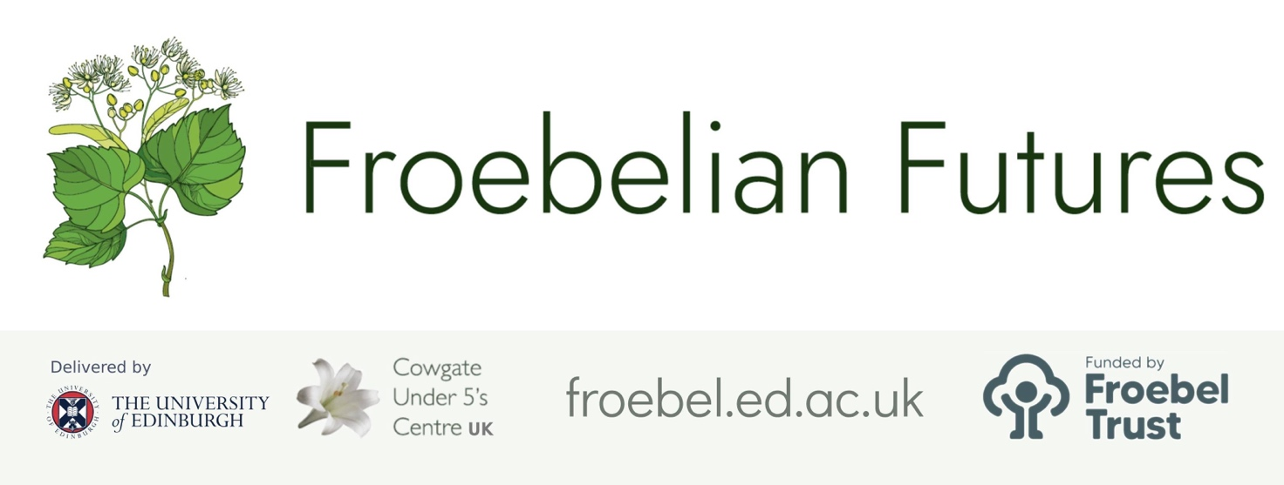

Practitioner Inquiry Project Report
Leadership opportunities & reflections

Project title

Documenting Young Children’s Learning Through a Froebelian Lens

Subtitle (if applicable)
Considering the documentation of children’s learning in a play based P1 setting.

Your name, role and setting
Daniel Champlin – Principal Teacher, Victoria Primary School and ELC

- What are the implications of this research for:

- The team/setting as a whole
- Pedagogy
- Resourcing
- Policy
- The sector / your networks / management beyond your immediate setting.

(Please aim to write between 250 minimum and 500 words maximum, using the box below. Please do not disclose the identity of any individuals in your comments, as this form will be part of your colleague’s public record of their project).

Giving learners autonomy and understanding over their own learning, next steps, etc. is not just something focused on by Froebel and in the early years but is in fact core to the Scottish curriculum, Curriculum for Excellence. Therefore, this project is hugely relevant not just in the early years but beyond.

Workload is a huge issue across the early years and the wider school environment, and if documentation is only being created by teachers and EYOs, for adult eyes, then it does not serve the purpose that it set out to serve. Therefore, if we able to successfully have children take ownership over the documentation of their learning, this both supports teachers and practitioners while at the same time ensuring that our young people are more confident and better able talk about their own learning and their successes.

Findings such as most children being engaged with their own wall display, together with the idea that these should be at child height so children can both access it and see it more easily, is something that as a setting, and in particular in the early years, we can try to implement over the coming months more widely. This also means that what is on display for the children is more relevant to them and gives them much more ownership over their own learning space, showing that we value them as individuals and that we are helping them with their independence and confidence.

Many nurseries, including or own, already do floorbooks really well but expanding this into P1 can prove to be really helpful for all P1 classes to do. This can give children something to be really proud of and help them to become more reflective learners, as it would give them something more concrete to show others and look back over at any point. It would also support when families are coming into the setting, as the children are then able to show their learning more effectively and be encouraged to develop the vocabulary of learning, as they would be expected to be able to explain what the learning was that was happening in the photos.

It is interesting, and unfortunate, that there was not much engagement with the 'make, do, write, say' wall. Though this was not necessarily a successful way to get children involved in their own learning, going forward it could at least be a helpful way for teachers and practitioners to collect children’s voice and visually display what is being learned now and what is coming up. This could be seen both as an aid as well as a tool to help add structure to the learning of our young children, particularly of those with ASN who require visual aids and more control over what is coming up next.

- What value do you place on practitioner-research – and what more can be done in your setting/locality to enable it to continue as part of routine practice going forward? (100 word approx.)

Our school and setting as a whole has always placed a lot of value on practitioner research and certainly this project has important messages for P1 and early years around how to document their learning. At our next meeting as an early level I will ensure there is time for these findings to be shared so that this can be enabled to have an impact next year. I hope that across P1 and our ELC next year we will see more evidence of children being actively involved in things such as wall displays and floorbooks that particularly proved to be useful and helpful.

- What have you learned as a leader through supporting this research / programme? (100 words approx)

The key message from this research that I will ensure that I take forward – and share with the rest of our SLT team – is that so often the school in particular can be prone to limiting some pupil voice/engagement activities to older children, such as pupil council. This project reminds us that even the youngest of children are able to express an opinion, get involved in their own learning, and make an impact that shapes their own next steps and our wider school life. Ensuring their views are captured in a way appropriate to them to positively affect their own learning and our school community is something we need to ensure is always happening.

Please save this document as a PDF and share it as feedback with your researching practitioner/colleague and with us at froebelianfutures@ed.ac.uk. Please ask them to upload it to their project report page (Edit > Question 12) as a condition of completing their certificate.
If you have any questions about this process please contact us at the email address above.

